Journal 1-2

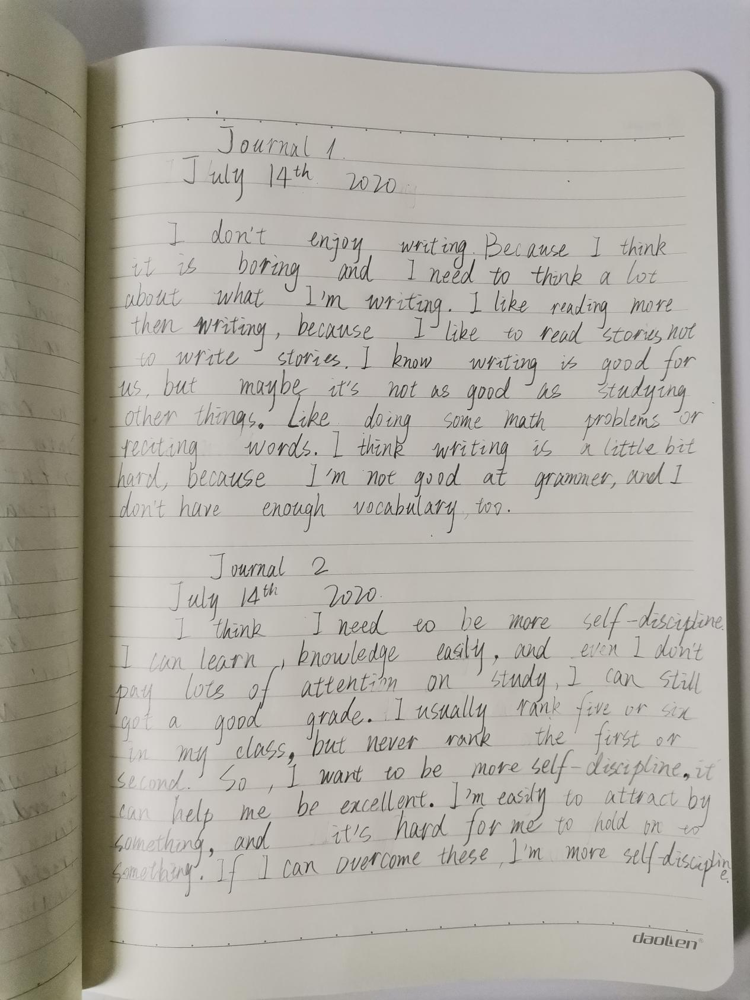

W6A – Lesson 3, Journal 3-4, Draft 1

Sophia Yu

2020.7.19

**Journal 3 Prompt: What unexpected thing happened to you recently? Why?**

My family and I went climbing on July 16th 2020. During the coronavirus pandemic, we stayed at home all day, and hardly did exercise. we decided to go climbing the mountains and breath some fresh air the day before.

Next day morning, my parents’ legs were very painful, but mine were not. It’s really beyond my expectation! Because last year after we climbed the mountains, my legs were a little bit hurt. We just stayed at home, studying, and never playing with my friends this year, but my legs weren’t hurt.

Then I realized, though I was at home, I had dancing class online every week, and it made my body hurt every time. When we were climbing the mountains, we slowed down. Perhaps that is why my legs weren’t get pain.

**Journal 4 Prompt: What are three reasons why the global pandemic is good?**

The three reason why the global pandemic is good:

First, people pay more attention to their health and habits. They have increased the frequency of hand washing, put more emphasis on exercise and healthy diet. Second, there are more institutes to research coronavirus, that promotes development of modern science. And people are adept to studying or working online. This promotes the development of information technology. Third, people have increased their awareness of protecting wild animals, which not only protect themselves, but also respect nature.

W6A - Lesson 7, Journal 9-10, Draft 1

Sophia Yu

2020/07/28

**Journal 9 Prompt:*What does it mean to have integrity?***

Integrity means follow the rules, not doing anything against law and morality. Punishing the evil, promoting the good, and doing justice. A man of integrity will not be disturbed by external things, insist on doing the right and kind things. Or a man of integrity will not hesitate to help others when they are in trouble.

**Journal 10 Prompt:*What is the hardest lesson you’ve ever had to learn? Why?***

The hardest lesson I’ve ever had is the violin lesson. Because I had the violin lesson when I was four years old, and let a four-year-old girl play an instrument, it’s very difficult for me. I need to have the lesson once a week, but I have to practice the violin every day, because if I get a rest one day, I’ll become unskillful. I have to learn how to read the musical notation, learn the fingering of four strings on violin, and have to hold the violin bow. So, it’s very hard for me to had the violin lesson. But when I was ten, the doctor said if I don’t have to continue learning the violin, I’d better give up because my myopia has a lot to do with practicing. After much consideration, we gave up learning the violin, but since then, there has never been such a difficult lesson as violin.